CFD Aerodynamic Analysis and Combustion Visualization in a Fluidized Bed Using Vertical Separated Jets
Khairy H. El-Nagar
Mechanical engineering department, Benha University, Shoubra faculty of Engineering, 108 Shoubra Street , Cairo, Egypt

Abstract
The aim of the present work is to study and test a new design for distribution plate in a fluidized bed with existence of special ejector to enhance the swirl phenomena through the bed. A Computational Fluid Dynamic (CFD) simulation technique was utilized to study the aerodynamic using fluent software and then the results were compared to the experimental results. The experimental measurements depend mainly on the visualization technique using Pyrex glass tube for combustion. Video captures were utilized to study the performance of the new plate design.
The obtained results showed a good performance in different aspects where good mixing and swirl flow, fast ignition response, no region for de-fluidization in the center of the plate, simple to be manufactured and maintained are some of the new design features.
The CFD aerodynamic simulation showed that there are many swirls were generated at different levels of the bed which means a good effect of the new design on the combustion efficiency and the distribution of the sand particles.

Key words: Fluidized bed, Distributer plate, Swirling jets, Aerodynamics, Wall effect

- Introduction
The phenomenon of gas-solid fluidization is widely used in chemical, petroleum, metallurgical, and energy-related technologies. This technique has been used since the early years of the twenties century. Fluidized bed consists of a collection of solid particles which is subject to upward flow of air and fuel. By increasing the fluid flow rate slowly, balance state is reached where the particles are free to move. In this case the behavior of the system is similar to that of fluids which is called ‘fluidization’. Increasing the flow rate above that will cause the bed to expand uniformly until a critical flow rate is reached. Swirl flow can improve the quality of combustion in fluidized beds. In combustion systems, the strong favorable effect of applying swirl to inject air and fuel are extensively an aid for stabilization of the high intensity combustion process and efficient clean combustion process.
Due to the advantages of fluidized bed reactors, a large amount of research is devoted to this technology. Most current research aims to quantify and explain the behavior of the phase interactions in the bed. Specific research topics include particle size distributions, various transfer coefficients, phase interactions, velocity, pressure effects, design of distributors and computer modeling.
Many parameters, such as pressure drop, bed geometry, solid size and density, can affect the solid flow structure in a fluidized bed [1-4].
Knowledge of solid motions and flow structures in fluidized beds is of significant importance to a number of industrial processes.
Several experimental methods have been used to explore the mechanisms underlying the flow patterns based on optical measurements, such as particle image velocitymeter, fiber probes, and laser Doppler anemometry (LDA) [5-8]. Digital image processing was successfully applied to pre-process the obtained image sequences and to gain a deeper insight into the observed flow structures. Using specific image processing methods, shapes and velocities of the flow structure can be calculated [9].
A better understanding of the dynamics of fluidized beds is a key issue in making improvements in efficiency. Computational fluid dynamics (CFD) is an emerging technique and holds great potential in providing detailed information of the complex fluid dynamics [10]. An Eulerian–Eulerian model incorporating the kinetic theory of granular flow to describe the gas– solid two-phase flow in fluidized bed polymerization reactors was applied. The model parameters were examined, and the model was validated by comparing the simulation results with the classical calculated data. The effects of distributor shape, solid particle size, operational gas velocity and feed manner on the flow behavior in the reactor were also investigated numerically [11].
The clear observation of solid mixing inside a dense fluidized bed is hardly possible through sophisticated experimental techniques. Consequently, numerical simulation can be proposed and exploited to provide an insight into the solid mixing within the fluidized beds. Fortunately, the recent progress in the computational methods, especially computing resources, has allowed carrying out of detailed simulations of many aspects of the complex phenomena occurring in the particulate systems [12]. Furthermore, the use of the discrete particle model (DPM) enables the simultaneous ‘measurement’ of several properties, such as the gas, which is difficult if not impossible to achieve by direct experimentation. Provided that computer models possess sufficient predictive capabilities, they have the additional advantage over experiments that several design options and operation conditions can be tested relatively ease [20]. The effects of superficial gas velocity, presence of draft tube and type of sparring on the solid hold-up and solid circulation patterns were studied with the help of experiments and CFD simulations [14]. A 2-D multiplied Eulerian model integrating the kinetic theory of granular flows was developed in this study.
A numerical study of gas and solid flow in an internally circulating fluidized bed (ICFB) was performed by Feng et. al [15]. The gas and solid dynamics has been calculated using the commercial computational fluid dynamics (CFD) software package ANSYS/Fluent and an Eulerian–Eulerian model (EEM) with kinetic theory of granular flow used to calculate solid stresses. A two dimensional geometry was used to represent key parts of a laboratory ICFB. Simulations were conducted to assess the effect of changing four designs or operating parameters which are: gas distributor plate angles, presence of a heat exchange tube bundle, superficial fluidizing velocities and initial solid packing heights. A computational fluid dynamics (CFD) model was used to investigate the hydrodynamics of a gas–solid fluidized bed with two vertical jets in [16]. A commercial CFD code, CFX 4.4, together with user-defined FORTRAN subroutines were employed for this purpose.
The aim of the present work is to study and test a new distribution plate for fluidized bed with the existence of special ejector to enhance the swirl phenomena through the bed. CFD was utilized to study the aerodynamic analysis using fluent software and then the results were compared to the experimental results. The experimental measurements depend mainly on visualization technique.

- Experimental test facility
Pressurized air is delivered through two main Inlet tubes and passes through the air distributors. When the fluid is passed upward, frictional resistance with sand particles increases with increasing fluid flow. Minimum fluidization is reached when the upward drag force exerted by the fluid on the particles is equal to the apparent weight of the particles in the bed and this is the perfect situation for combustion. Figure (1) shows a 3-D schematic diagram for the test rig used in the present study. In case of combustion (hot run test rig, figure (2)) natural gas is injected in the air stream to have a homogenous mixture before the combustion region.

II.1 Distributor Plate Description
The main item of the new proposed design is the ejector part shown in figure (3). It consists of a non throughout hollow taper cylinder with three levels of horizontal holes of 2.2 mm diameter each. The number of holes for each row is 10 holes which are distributed circumferentially. This ejector is used as a swirl generator on the distribution plate of the fluidized bed. Five of them are fixed on the surface of the distribution plate as shown in figure (3).
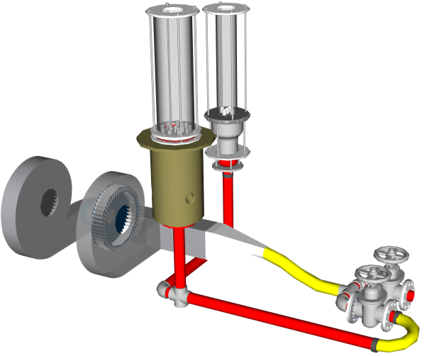
Figure (1) 3-D diagram for fluidized bed system main parts
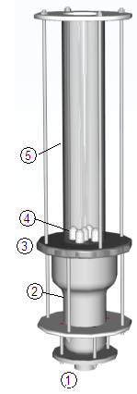 | 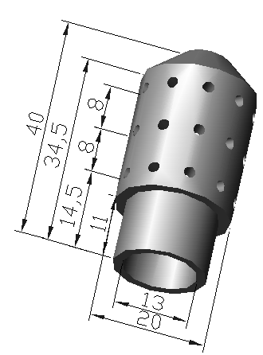  (a) Ejector details | 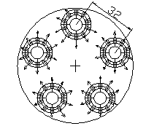  (b) Distributor plate ejector configuration
Figure (2) Layout of hot run test section  1-Inlet pipe for tested section 2- Diffusion section 3- Distributor plate, 4- Five Distribution Ejectors 5- Pyrex tube. | Figure (3) Distributor Configuration

II.2 CFD Aerodynamic Model description
Fluid Dynamics or CFD is the analysis of systems involving fluid flow, heat transfer and associated phenomena such as chemical reactions by means of computer-based simulation. The technique is very powerful and spans a wide range of industrial and non-industrial application areas. The design fluidized bed distributor plate relies on experience and coefficients which originate from test data. The availability of relatively inexpensive computers with high computing powers has fostered the development of numerical methods which are able to solve the 3-dimensional Navier- Stokes-equations in complex components with reasonable effort. Therefore, numerical methods are used also in the industry with the object of optimizing the and to increase the reliability of performance prediction and thus to reduce testing costs.
An aerodynamic study by using fluent CFD as a tool was utilized to investigate the performance of the distribution plate ejector suggested design. CFD mesh for the distributor ejector, figure (4), was generated by gambit software. The ejector was generated with the same dimensions shown in figure (3). Only one ejector was considered in this case. The volume generated is repeated periodically to minimize the grid number of cells. The grid number that generated is about 350,000 cells.
A fluent CFD 6.3.2 was used to solve the generated mesh with (k- ε) model [17]. The model transport equations for the turbulence kinetic energy and the specific dissipation rate are listed in reference [10]. The inlet velocity of the model was controlled not to exceed the terminal velocity. Terminal velocity is calculated according to the following equation, [18].

$U_{t}={\left[0.072g\frac{d_{p}^{5/8}(ρ_{s}-ρ_{g})}{ρ_{g}^{2/5}μ_{g}^{3/5}}\right]}^{5/7}$
Where U_{t} is defined as the maximum speed the bed could operate without problem in sand removing.

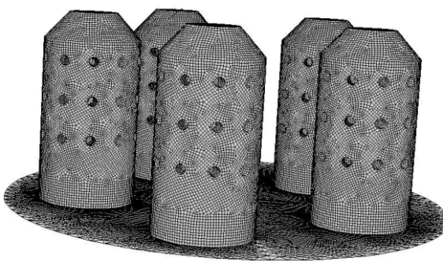

Figure (4) surface mesh of the ejectors

- Results and discussions
III.1 CFD Aerodynamic Model results
Figure (5) represents the velocity contour for the new plate design with CFD simulation at the three levels of the horizontal holes of the ejector. The first level is the bottom level where jets speed is clear which means that the driving force for the bottom of the plate is maximum and the swirl of the jets coming from the horizontal holes is clear. For the second level of the holes the jet is mixed with the flow coming from the first level so the jets speed strength starts to decay which means that the driving force is started to be equally distributed along the section of the plate. The upper level of the horizontal holes shows more decay for jets coming out from the horizontal holes which means that the distribution of driving force is more homogenous and swirl starts to be generated at this level.
Figure (6) represents a velocity vector at levels 5cm and 6 cm above the bed level. It could be noticed that there are about ten vortex generated at level 5 cm. This vortex is generated from large number of smaller vortices generated at lower levels and collected together to form these ten vortices. At level 6 cm it could be noticed that the lateral vortex remaining as it is. At the middle the vortices start to combine together to form a bigger vortex. This means that the bed will rise from the middle and spill on the lateral sides so that the bed will be homogenous in temperature distribution due to good mixing process.
Figure (7) represents the contour of velocity for the aerodynamic tested volume at vertical section. The maximum speed exits at the lower part of the section in the middle of the bed. This means that the maximum pressure of the bed will be in the middle and consequently the bed sands will spill from the middle to the outer circumferential of it which means a good heat transfer rate from the bed to the wall.

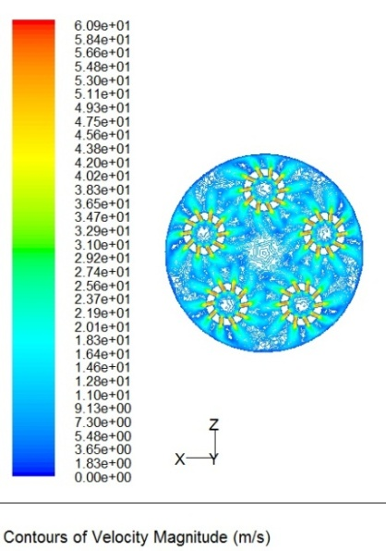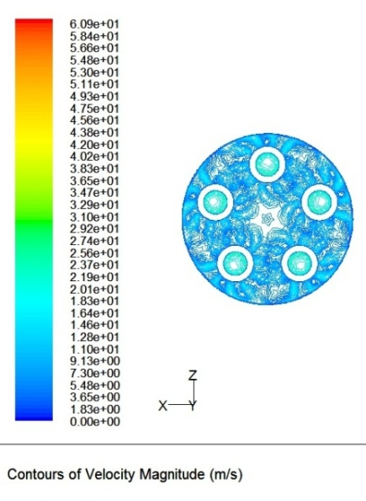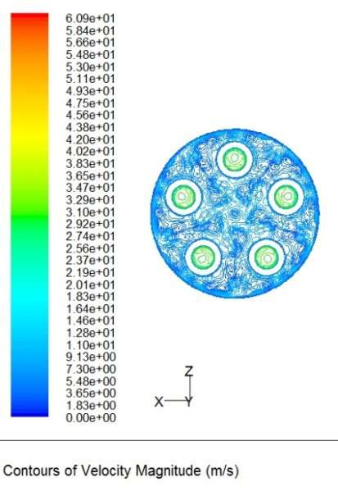
- At low raw of nozzles (b) At medium raw of nozzles (c) At upper raw of nozzles

Figure (5) Contour of velocity distribution through cross section at three levels of ejectors holes for the distribution plate.

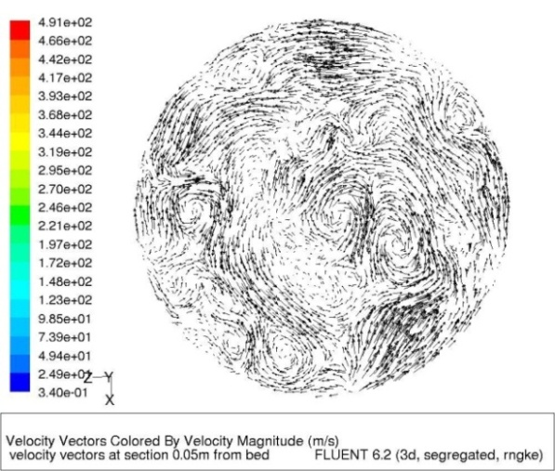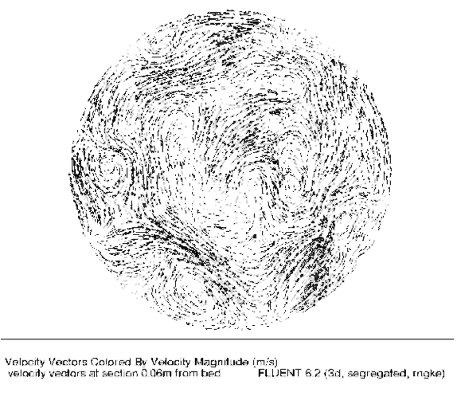

Figure (6) Contour of Velocity distribution for the distributed plate at 5 Cm and 6 Cm levels above the base plate plane with
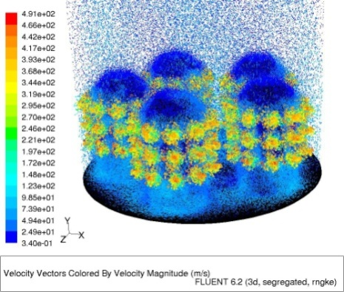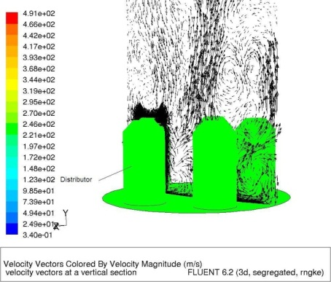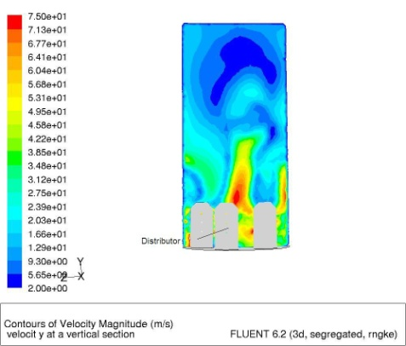

Figure (7) Velocity distribution of the fluid flow at vertical section of the bed
III.2 Experimental Results
A hot run test was performed for the distributor plate with ejectors as shown in figures (8-10). The use sand size was 600 um. A mixture of air and methane was used as combustible mixture. The stream flow speed of the mixture is the same as that used in CFD aerodynamic simulation.
When the run starts before ignition stage the bed was uniform in distribution with radial and axial steering of sand. This uniformity in steering helps in fast ignition of the bed. The bed is quit and discipline as quit sea. After that the ignition starts. There are three combustion stages in fluidized bed which are: ignition, starts of combustion and normal combustion stages. The photos of the ignition process of the bed at hot run test to examine experimentally the new distribution design are introduced in the following figures. The process of hot run test was recorded by video camera and then capture was extracted from the resulted movie as separated frames. The first frame introduced as start for each stage and the last frame introduced as end frame.
Figure (8) introduces the ignition process. The process starts with flame on the bed surface where the combustion starts by exhibiting a blue flame which gradually starts to disappear. This means that some of sands start to be hot and the combustion is concentrated in the center of the bed with a little blue color at the outer wall of the bed. In this case the bed itself has two layers; one layer has a good mixing and it is located near the flame, the upper one. The other layer, the lower one which is close to the wall, has a little settling. This means that the sand have good mixing process in the center of the bed. Finally the flame over the bed starts to disappear and the next stage of combustion is dominating.
Earlier observations have already shown that burning a gas in a bubbling fluidized bed differs from burning it on a conventional burner. The most important difference is that combustion in a fluidized bed is not a truly continuous process, even if it appears steady and flameless. The gases were burned either above the surface of the bed or explosively in bubbles rising through the bed. The process is accompanied by acoustic and visual effects, which were always observed during the combustion of gaseous fuels in bubbling beds of inert particles .Pressure pulsations, are detectable both in the freeboard and below the distributor, in the wind box [19]. When mixtures of methane and air are burned in a bubbling fluidized bed of inert particles, with bubbles rising through it, combustion does not take place throughout the volume of the bed, but is concentrated at a certain distance from the distributor.
Figure (9) shows the start of combustion stage. In this experiment, as the fluidization velocity is relatively small, the movement of the bed material is rather quiet. However, quick movement can be seen occasionally. This quick movement of bed material was caused by the bubble movement. The particles movement owing to the attraction of void wake can be observed in frames number 4 and 5 of figure (9). Also it can observe some movement of the particles which was caused by the bubble movement along the periphery of the tube.
Thus, this area corresponds to the high heat transfer performance region. In this region the bubble’s rise velocity increases as mentioned before, and the particle’s velocity is faster than that of the movements in this area. However, it can be observed that the particles were attracted by the void wake, the particle moved a large distance, and thereafter some particles rose up. The bubbles start to be clear and continue which means that the process of steering is efficient. The process of bed transformation from starting of combustion mode to normal combustion mode is fast which takes about 5 seconds. This means that the rate of mixing is very high and homogenous. The movement of these particles and thus bed material behavior are rather complicated.
Figure (10), Represents the complete combustion process. Flow in this bed is characterized by strong local recirculation and bypassing of gas through the vertical columns of jets. The effect of the vertical jets makes the gas–solid flow quite different from conventional bubbling fluidized beds by a greater amount of solids being thrown into the freeboard. The bed pressure is closely related to solid volume fraction, or dynamic solid holdup. Also the solid hold-up in the freeboard is higher than that in conventional bubbling fluidized beds. Correspondingly, the pressure is high and the pressure difference in the bed provides a driving force for solid and gas flow from the bottom to freeboard. Strongly swirling flows (approximately S ≥ 0.6) possess sufficient radial and axial pressure gradients to cause a central toroid recalculation zone [20]. This is not observed at weaker degrees of swirl. This strong swirling vortex region helps to meet many of the combustor performance requirements. The main notice is that there are no hot spots on the bed or sands and no de- fluidization regions. Also the generated swirl is up-word and side-word. All of this help keeping the base plate without deformation from hot spots and no needs for adding de-colliding mechanism or material which mainly reduces the cost of operation.

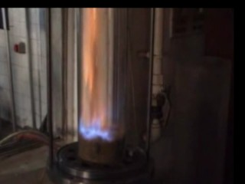 | 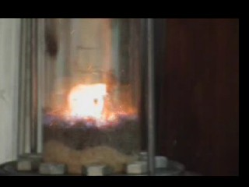 | 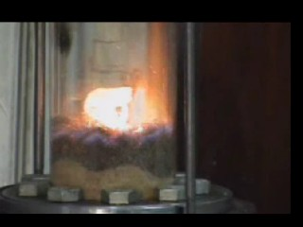 | 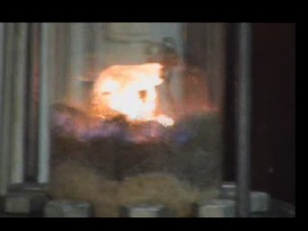 | 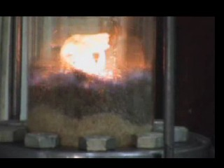
1-Start | 2 | 3 | 4 | 5- End
Figure (8): Ignition stage

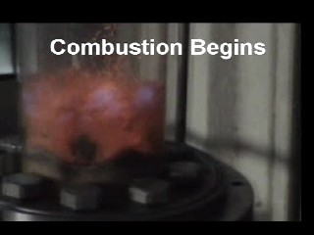 |  |  | 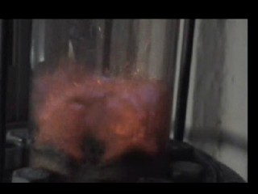 | 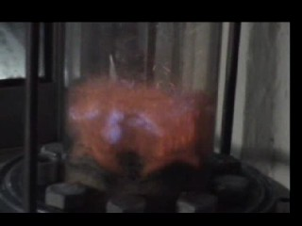
1-Start | 2 | 3 | 4 | 5-End
Figure (9): Starting of combustion stage

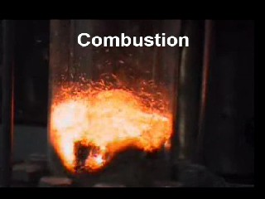 | 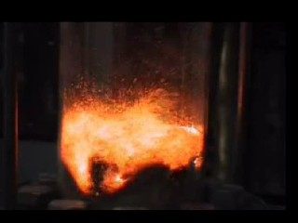 | 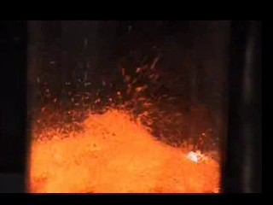 | 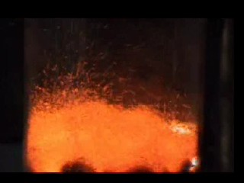 | 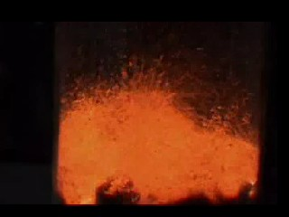
1-Start | 2 | 3 | 4 | 5-End
Figure (10): Combustion stage

- Conclusion
The present work introduces an experimental and theoretical study of a new plate design. The obtained results showed a good performance in different aspects where good mixing and swirl flow, fast ignition response, no region for de-fluidization in the center of the plate, simple to be manufactured and maintained are some of the new design features.
The CFD aerodynamic simulation showed that there are many swirls were generated at different levels of the bed which means a good effect of the new design on the combustion efficiency and the distribution of the sand particles.
The hot run showed good distribution of the bed temperatures. Good mixing near the side wall which means good heat transfer for the bed wall. Short time from the ignition to the complete combustion state was noticed. But there is a little settling on the bed bottom due to the needs for more ejectors to be added on the bed distributing plate which can be proposed for future work.

Nomenclature
$U_{t}$ : Terminal velocity m/s
$g$ : Gravity acceleration m/s²
$d_{p}^{}$ : Particle diameter
$ρ_{s}$ : Density of solid phase (kg/m³)
$ρ_{g}$ : Density of gas phase (kg/m³)
$μ_{g}^{}$ : Viscosity of gas phase (N.s/m²)

References
[1] Xianfeng Fan, Zhufang Yang, David J. Parker , Impact of solid sizes on flow structure and particle motions in bubbling fluidization , Powder Technology 206 (2011) 132–138.
[2] G.N. Ahuja, A.W. Patwardhan, CFD and experimental studies of solids hold-up distribution and circulation patterns in gas–solid fluidized beds ,Chemical Engineering Journal 143 (2008) 147–160 .
[3] B. Peng, C. Zhang, J. Zhu,Numerical study of the effect of the gas and solids distributors on the uniformity of the radial solids concentration distribution in CFB risers, Powder Technology 219(2012) 78–85.
[4] Peter N. Loezos, Paola Costamagna1, Sankaran Sundaresan , The role of contact stresses and wall friction on Fluidization , Chemical Engineering Science 57 (2002) 5123 – 5141
[5] Gaurav Agarwal, Brian Lattimer, Srinath Ekkad, Uri Vandsburger , Influence of multiple gas inlet jets on fluidized bed hydrodynamics using Particle , Image Velocimetry and Digital Image Analysis , Powder Technology 214 (2011) 122–134.
[6] F. Bonniol , C. Sierra, R. Occelli, L. Tadrist , Similarity in dense gas–solid fluidized bed, influence of the distributor and the air-plenum , Powder Technology 189 (2009) 14–24.
[7] H. Schneidera, Ch. Proustb, Determination of turbulent burning velocities of dust air mixtures with the open tube method, Journal of Loss Prevention in the Process Industries 20 (2007) 470–476 .
[8] Xuecheng Wu, Qinhui Wang , Zhongyang Luo, Mengxiang Fang, Kefa Cen , Experimental study of particle rotation characteristics with high-speed digital imaging system , Powder Technology 181 (2008) 21–30 .
[9] U. Lackermeier, C. Rudnick, J. Werther), A. Bredebusch, H. Burkhardt, Visualization of flow structures inside a circulating fluidized bed by means of laser sheet and image processing, Powder Technology 114_2001.71–83 .
[10] Yuqing Feng , Tim Swenser-Smith, Peter J. Witt, Christian Doblin, Seng Lim, M. Phil Schwarz, ,CFD modeling of gas–solid flow in an internally circulating fluidized bed , Powder Technology 219 (2012) 78–85.
[11] Xi-Zhong Chen, De-Pan Shi, Xi Gao, Zheng-Hong Luo,” A fundamental CFD study of the gas–solid flow field in fluidized bed polymerization reactors”, Powder Technology 205 (2011) 276–288

[12] H.R. Norouzia, N. Mostoufia , Z. Mansourpoura , R. Sotudeh-Gharebagha , J. Chaoukib Characterization of solids mixing patterns in bubbling fluidized beds , chemical engineering research and design 8 9 ( 2 0 1 1 ) 817–826 .
[13] N.G. Deen, M. van Sint Annaland, M.A. van der Hoef and J.A.M. Kuipers , Review of discrete particle modeling of fluidized beds , Chemical Engineering ScienceCES 6886.
[14] G.N. Ahuja, and A.W. Patwardhan ,CFD and experimental studies of solids hold-up distribution and circulation patterns in gas–solid fluidized beds , Chemical Engineering Journal 143 (2008) 147–160.
[15] Yuqing Feng, Tim Swenser-Smith, Peter J. Witt, Christian Doblin, Seng Lim, M. Phil Schwarz , CFD modeling of gas–solid flow in an internally circulating fluidized bed, Powder Technology 219 (2012) 78–85.
[16] Pei Pei, Kai Zhang, Jintian Rena, Dongsheng Wenb, Guiying Wu, CFD simulation of a gas–solid fluidized bed with two vertical jets, Particuology 8 (2010) 425–432.
[17] FLUENT 6.2 User’s guide 2005.
[18]
[19] Witold Z˙ ukowski, A simple model for explosive combustion of premixed natural gas with air in a bubbling fluidized bed of inert sand Combustion and Flame 134 (2003) 399–409.
[20] Nailu Chen , Bo Liao, Jiansheng Pan, Qiang Li , Changyin Gao, Improvement of the flow rate distribution in quench tank by measurement and computer simulation , Materials Letters 60 (2006) 1659–1664.

